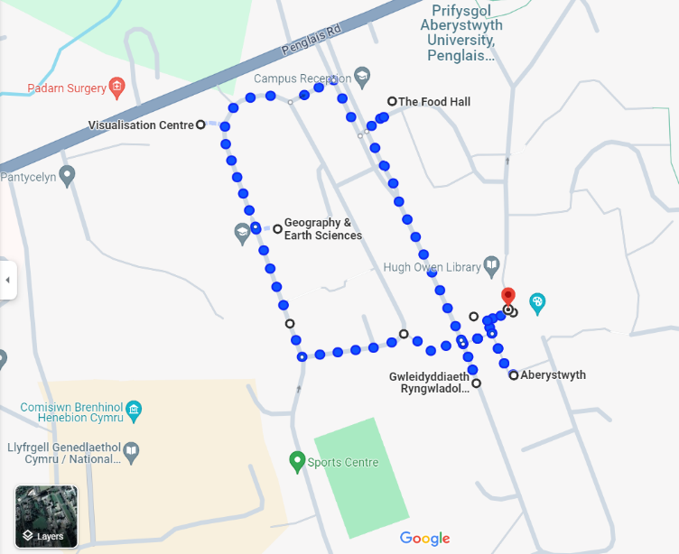

Thursday 25th Jan 2024

Dérive no. 4: Entrances

The Situationist International (1957 to 1972) were an avant-garde Paris-based collective who liked to explore certain places and critique their sociological meaning via special walks called dérives.

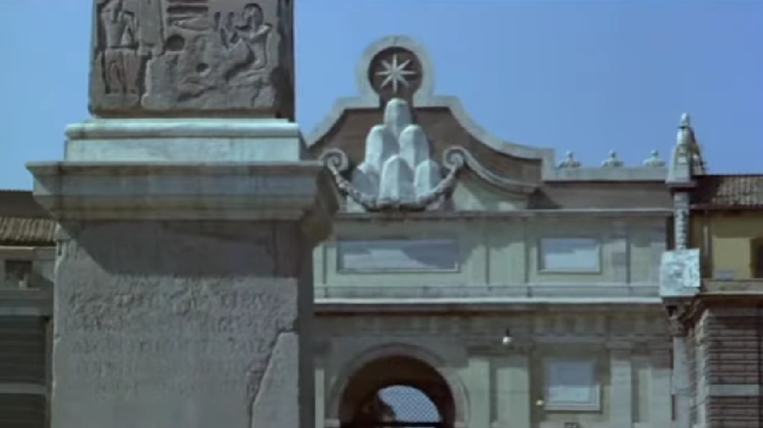

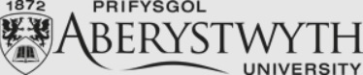


Join us 4pm at sliding doors of the Arts Centre to explore the different strange entrances around campus. At 5.30pm we will watch Peter Greenaway’s The Belly of An Architect in the Parry Williams Ciné, then discuss its comments on the built environment and its sometimes grotesque power.
The fourth event of the New Postgraduate Salon, for culture, discussion, & revelry.
R.S.V.P. to akg4@aber.ac.uk or ack5@aber.ac.uk, merci.

